Name:A.Shashidhar H.No:2303A51798 Batch:26
SCHOOL OF COMPUTER SCIENCE AND ARTIFICIAL INTELLIGENCE |  |  |  |  | DEPARTMENT OF COMPUTER SCIENCE ENGINEERING
Program Name: B. Tech |  |  |  | Assignment Type: Lab |  |  | Academic Year:2025-2026
Course Coordinator Name |  |  |  | Dr. Rishabh Mittal
Instructor(s) Name |  |  |  | Mr. S Naresh Kumar  Ms. B. Swathi  Dr. Sasanko Shekhar Gantayat  Mr. Md Sallauddin  Dr. Mathivanan  Mr. Y Srikanth  Ms. N Shilpa  Dr. Rishabh Mittal (Coordinator)  Dr. R. Prashant Kumar  Mr. Ankushavali MD  Mr. B Viswanath  Ms. Sujitha Reddy  Ms. A. Anitha  Ms. M.Madhuri  Ms. Katherashala Swetha  Ms. Velpula sumalatha  Mr. Bingi Raju
CourseCode |  |  | 23CS002PC304 | Course Title |  | AI Assisted Coding
Year/Sem |  |  | III/II | Regulation |  | R23
Date and Day  of Assignment |  |  | Week3 – | Time(s) |  | 23CSBTB01 To 23CSBTB52
Duration |  |  | 2 Hours | Applicable to  Batches |  | All batches
Assignment Number: 5.4(Present assignment number)/24(Total number of assignments)
 | Q.No. | Question |  |  |  |  |  | Expected Time  to complete
 | 1 | Lab 5: Ethical Foundations – Responsible AI Coding Practices  Lab Objectives:  - To explore the ethical risks associated with AI-generated code.  - To recognize issues related to security, bias, transparency, and copyright.  - To reflect on the responsibilities of developers when using AI tools in software development.  - To promote awareness of best practices for responsible and ethical AI coding.  Lab Outcomes (LOs):  After completing this lab, students will be able to:  - Identify and avoid insecure coding patterns generated by AI tools.  - Detect and analyze potential bias or discriminatory logic in AI-generated outputs.  - Evaluate originality and licensing concerns in reused AI-generated code.  - Understand the importance of explainability and transparency in AI-assisted programming.  - Reflect on accountability and the human role in ethical AI coding practices.  Task Description #1:  • Prompt GitHub Copilot to generate a Python script that collects user data (e.g., name, age, email). Then, ask Copilot to add comments on how to anonymize or protect this data.  Expected Output #1:  • A script with inline Copilot-suggested code and comments explaining how to safeguard or anonymize user information (e.g., hashing emails, not storing data unencrypted).  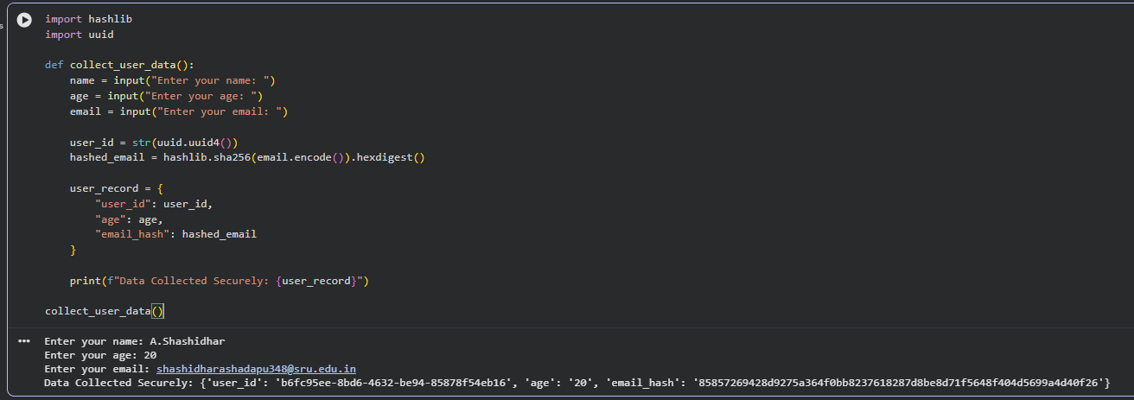  Task Description #2:  • Ask Copilot to generate a Python function for sentiment analysis. Then prompt Copilot to identify and handle potential biases in the data.  Expected Output #2:  • Copilot-generated code with additions or comments addressing bias mitigation strategies (e.g., balancing dataset, removing offensive terms).  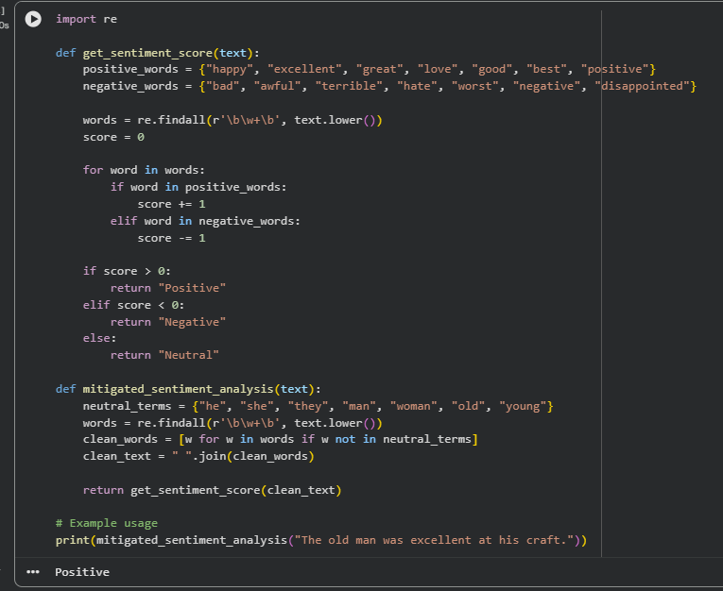  Task Description #3:  • Use Copilot to write a Python program that recommends products based on user history. Ask it to follow ethical guidelines like transparency and fairness.  Expected Output #3:  • Copilot suggestions that include explanations, fairness checks (e.g., avoiding favoritism), and user feedback options in the code.  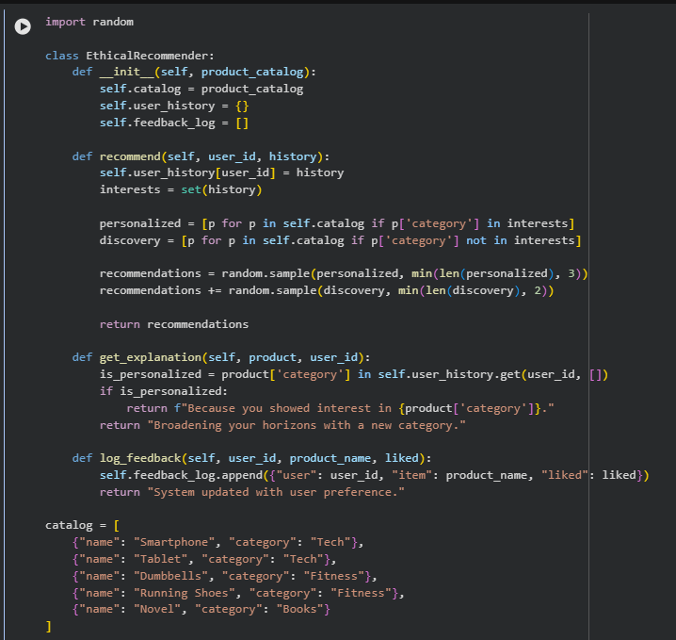  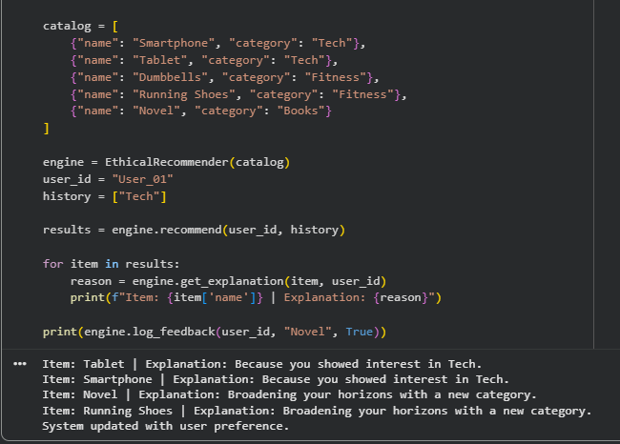Task Description #4:  • Prompt Copilot to generate logging functionality in a Python web application. Then, ask it to ensure the logs do not record sensitive information.  Expected Output #4:  • Logging code that avoids saving personal identifiers (e.g., passwords, emails), and includes comments about ethical logging practices.  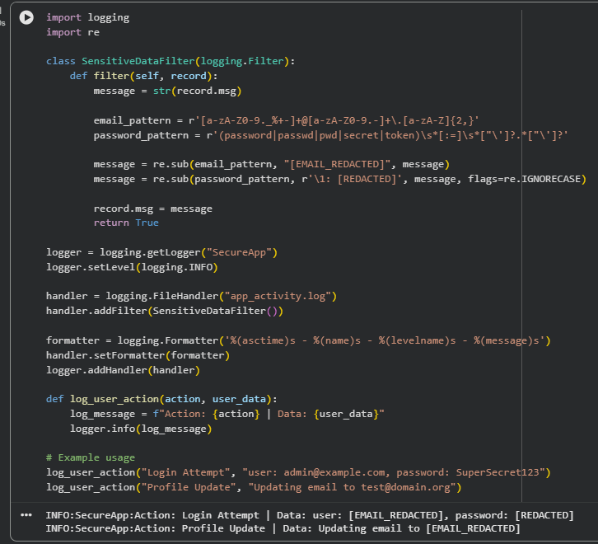  Task Description #5:  • Ask Copilot to generate a machine learning model. Then, prompt it to add documentation on how to use the model responsibly (e.g., explainability, accuracy limits).  Expected Output #5:  • Copilot-generated model code with a README or inline documentation suggesting responsible usage, limitations, and fairness considerations.  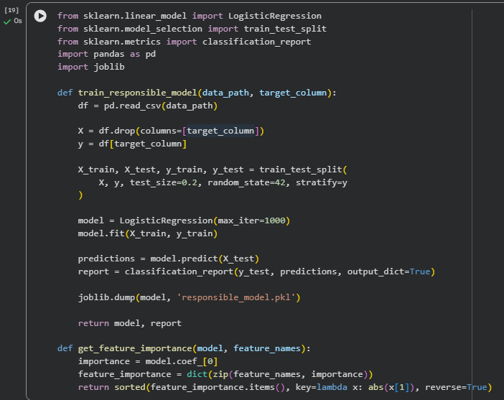  Note: Report should be submitted a word document for all tasks in a single document with prompts, comments & code explanation, and output and if required, screenshots |  |  |  |  |  | Week3 -

